A Major Project Final Defense Report on
Construction and Implementation of Neural Network Library

Submitted in Partial Fulfillment of the Requirements for
the Degree of Bachelor of Engineering in Computer engineering
under Pokhara University

Submitted by:
Diwash Ale, 15358
Nisseem Rana Magar, 15377
Bikash Singh, 15371
Nischal Hada, 15373

Supervisor:
Kamal Chapagain

Date:
25th Nov 2019


Department of Computer Engineering
NEPAL COLLEGE OF INFORMATION TECHNOLOGY
Balkumari, Lalitpur, Nepal.

ACKNOWLEDGEMENT

This project would not have been possible without the joint efforts of many individuals. It has been a pleasure for us to acknowledge the assistance and contributions that were very important and supportive throughout the project. We would like to extend our sincere thanks to all of them.
We owe special thanks to a number of people who has devoted much of their time and expertise without which it would have been very difficult for us to complete our project entitled “Construction of neural network library and its implementation”.
We are highly indebted to our supervisor Kamal Chapagain for his valuable guidance throughout the project development period and for providing technical support with suggestions which helped our project to grow and foster to a certain level we didn’t think of reaching in such a short period.
We would like to extend our special thanks to Roshan Chitrakar for his technical guidance, valuable suggestions, attention and time for our project.
Last, but not the least, we would like to thank our teachers and colleagues who have been knowingly or unknowingly the part of this project and lent support and views during the entire development time.

ABSTRACT
Artificial Neural Network (ANN) is a computing system made up of a number of simple, highly interconnected processing elements, which process information by their dynamic state response to external inputs. This project is about understanding how neural networks work and making our own basic neural network that can be trained to solve problems. We first created our own perceptron which is the basic element of neural network and tested them for logical gates. Problems that can and cannot be solved by the perceptron are determined. Then we created library for multilayer perceptron, 2-layer network in particular with the help of perceptron. Logical gate problems such as XOR and XNOR that single perceptron cannot solve are solved with this NN library. Now finally this library is used to train NN that will be able to recognize handwritten digit. This library is used for creating an agent that learns to play video game such as T-rex run (Google’s Dino game) with the technique called Neuroevolution of augmenting topologies (NEAT). At the end stage, for its real life uses, we have created an application using this library that predicts the name of disease based on the symptoms inputted or occurred.

Keywords: Back propagation, Deep Learning, Feed Forward, Fully Connected, Gradient Descent, Multilayer Perceptron, Neural Network, Neuroevolution (NEAT), Perceptron, Supervised Learning

LIST OF FIGURES
Figure 1: Iterative Model
Figure 3: NeuralNetwork Class Diagram
Figure 2: Percpetron Class Diagram
Figure 4: TRex game Class Diagram
Figure 5: Image Recognition Model
Figure 6: Learning Agent Model
Figure 7: Perceptron
Figure 8: FeedForward Neural Network
Figure 9: Neural Network Structure
Figure 10: Digit Recognition Program
Figure 11: XOR gate Visualization
Figure 12: Gantt chart for the overall phase
TABLE OF CONTENTS
ACKNOWLEDGEMENT…....................…......….………........….……......……………......................I
ABSTRACT ...…………..................…........................…........................….......................................II
LIST OF FIGURE….……….......…............…………...….....................….…..................................III
1. INTRODUCTION ......…..…..…....….................….....................…..........................................1
1.1. Problem Statement ......…......................…….................….…..............................……...2
1.2. Project Objectives …...…...…......…......…..................…......…...........….......................3
1.3. Scope and Limitation.……........….....….…...…................….......…....….…................. 4
2. LITERATURE REVIEW………..…………….….…............……..…......…..……………......5
3. METHODOLOGY..........…..…….....................…......................…..................….....................7
3.1. Software Development Life Cycle.............................…..........................…......…..........7
3.1.1. Requirement Analyze Phase.…......…................................................…................8
3.1.2. Design Phase...............……….…..…........................................................….........8
3.1.3. Coding Phase...............................……..............…...…….......................…...........8
3.1.4. Testing phase...................................…...................................................…............8
3.2. Tools and Technologies Used. ....…….............................…...........................................9
3.3. System Design..................................................................…............…………….... ....10
3.3.1 Class Diagram..................................…....................................…………….... ....10
3.3.2 Network Model Design.............................…...........................…………….... ....12
4. PHASES AND IMPLEMENTATION………….....................................................................14
5. RESULT AND DECISION……………..................................…….........................................18
6. CONCLUSION……………...……….….......……................……...…………………………20
7. RECOMMENDATION……..……….….......……................……...…………………………20
8. PROJECT TASK AND TIME SCHEDULE…....…....…..........…….………………………..21
8. REFERENCES…......………………………………..…………………………..……………20
9. APPENDIX,,,,,,…………..…………..................….….......………..……..…………………..22
1. INTRODUCTION
A neural network is a population of neurons interconnected by synapses to carry out a specific function when activated inside human brain. Artificial Neural Network (ANN) emerged from this drive for biologically inspired intelligent computing and went on to become one of the most powerful and useful methods in the field of artificial intelligence.
This Library contains functions that are required for a perceptron and neural network to work. Perceptron is the basic and key element for our Neural Network. It is an algorithm for supervised learning of binary classifiers. This algorithm enables neurons to learn and processes elements in the training set one at a time. A multilayer perceptron (MLP) is a class of feedforward artificial neural network. An MLP consists of at least three layers of nodes: an input layer, a hidden layer and an output layer. We first implement perceptron algorithm that enable us follow the creation of multilayer perceptron algorithm.
With this library, neural network can be trained with known data as supervised learning in any problem domain, to give the outcome such as solving logical gates, predicting values, finding pattern, etc. It has the feature that shows the structure of the network. The training process of the NN can also be visualized that show how the weights and the biases of the network changes with each iteration of training phases. With this library we can also implement genetic algorithm on neural network that is about evolving neural network to its best form which is used as a brain for as learning agent in playing video games, robots carrying out specific tasks, etc. To depicts its real life uses, we have created an application using this library that predicts the name of disease based on the symptoms inputted or occurred.

1.1 Problem Statement
Deep learning is one of many machine learning algorithms to enable a computer perform a plethora of tasks such as some kind of prediction like stock prediction, house rent prediction or whether a person is eligible for a job or not, classification (like classifying images of dogs, cats). Deep learning uses the concept of neural networks to do its job. A neural network has been modeled after a human brain. Just like there are neurons in the brain for passing information, there are nodes in a neural network for doing a similar task. Nodes are nothing but mathematical functions [1].

“If you want to learn something, why not create it?”
We build this library to understand deeper about neural network basic working mechanism, algorithm and mathematical implementation. We can add new feature, algorithm and even modify existing algorithm according to our need. It becomes easy to understand it because we created it by ourselves and can be constantly updated with new features and optimization. There are lots of popular library for neural network such as Google’s TensorFlow, Microsoft Cognitive Toolkit (CNTK), Caffe from Berkeley Vision and Learning Center, Theano, Torch, etc. They contain lots of features that a person or organization may or may not want. These library and platform can be hard and confusing for beginner people or student that want get start with. Our library aims for those who is new to machine learning and neural network field; who want to learn about the basic concept and working mechanism of neural network.

1.2. Project Objectives
The main objective of our project is to construct and implement our own neural network library to solve logical gates problem, recognize the handwriting digits, create a learning agent that can be used for playing games and disease prediction. There are some specific objectives which are as follows-
- Create our own neural network library.
- Make our library as beginner friendly as possible.
- Make our library easily understandable for user about the mathematical concept of the neural nets.
- Make our library easier to use and implement it with many variable and target.
- Add feature to our library that show the structure of neural network with weights and biases.
- Add feature to our library that can visualize the training process of the neural network.
- Implement this library to solve the entire logical gate problem.
- Implement this library by training it to find patterns.
- Implement this to create a brain for the learning agent that can play games.
- Implement this library for solving complex problems in medical field like disease prediction algorithm.

1.3 Scopes and limitations
Our Neural Network Library has the power of flexibility. Once established, it can be applied to almost anything relative to its field. The core functionality of a neural net is to learn something efficiently, so if we have a system that can learn to recognize patterns, it could feasibly recognize patterns in almost any domain. Our Library can work easily on problems with many variables. For a problem with a large number of constrained inputs, it’s easy for our library to work out the answer.
With our Basic NN library, we are targeting the peoples who are interested in the field of Neural Networks and Machine learning. We have structured our library in a very simple manner which makes it easy for the users (being new or inexperienced) to implement the library. Due to the simplicity of our NN library it can be modified in any manner as required making it flexible/versatile. In our current state our NN library is capable of number recognition, separation of logic gates and is compatible with NEAT algorithm for genetic learning [2]. Companies that deals with machine learning and predicting their result and outcome can use this library with ease without having to deal with more complex and advance side of most of the popular libraries.
That said, there are also some key limitations prevent our library from its full potential. Our library is current based on feed forward neural net. System that requires other type of neural networks cannot be done with our current library. People with knowledge only about basic neural network but has no concept about programming can find it hard to implement our library for solving their problem. Space and time complexity can be issues with our library since less effort have been done in optimization of our library rather focus on the working neural network.

2. LITERATURE REVIEW
This section consists of the description of literature study done on the different topics directly related to the project. It aims to provide readers a theoretical base for the project and develop an understanding of the nature of the project.
The book [3] is about step-by-step gentle journey through the mathematics of neural networks and making own using the Python computer language. It contains a guide that starts from very simple ideas and gradually builds up an understanding of how neural networks work. The ambition of this guide is to make neural networks as accessible as possible to as many readers as possible. Part 1 is about ideas. It introduces the mathematical ideas underlying the neural networks, gently with lots of illustrations and examples. Part 2 is practical. It introduces the popular and easy to learn Python programming language, and gradually build up a neural network which can learn to recognize human handwritten numbers, easily getting it to perform as well as networks made by professionals. Part 3 extends these ideas further. It is about pushing the performance of the neural network to an industry leading by large margin only simple ideas and code, test the network on own handwriting and get it all working on a Raspberry Pi.
Neural Networks have been around for long time. Neural networks have been applied to a very broad range of tasks in many different disciplines. Several hundred reports have been published in recent years on attempts to apply neural networks to specific problems [4]. There are many popular libraries implementing different type of neural network. For example, Genann[5] is a minimal, well-tested open-source library implementing Feedfordward artificial neural networks (ANN) in C. It's entirely contained in a single C source file and header file, so it's easy to add to this project. [5] has a focus on being easy to use but is also very extensible. It has features such as: ANSI C with no dependencies, contained in a single source code and header file, fast and thread-safe, easily extendible, implements back propagation training. It is also compatible with alternative training methods (classic optimization, genetic algorithms, etc.) and includes examples and test suite. It is released under the zlib license - free for nearly any use.
Similarly, one of the most popular library existing around is TensorFlow[6] which is a free and open-source software library for dataflow and differentiable programming across a range of tasks. It is a symbolic math library and is also used for machine learning applications such as neural networks. It is used for both research and production at Google. TensorFlow was developed by the Google Brain team for internal Google use. Currently, it is the most famous deep learning library in the world. Google uses these deep neural networks to improve its services such as Gmail, Google Photo and Google search engine. They build a framework called Tensorflow to let researchers and developers work together on an AI model. It was first made public in late 2015, while the first stable version appeared in 2017. Tensorflow architecture works in three parts: Preprocessing the data, Build the model, Train and estimate the model. It is called Tensorflow because it takes input as a multi-dimensional array, also known as tensors. We can construct a sort of flowchart of operations (called a Graph) that we want to perform on that input. The input goes in at one end, and then it flows through this system of multiple operations and comes out the other end as output. This is why it is called TensorFlow because the tensor goes in it flows through a list of operations, and then it comes out the other side.

3. METHODOLOGY
We have planned to work by following these methodologies for the application of knowledge, skills, tools and techniques to a broad range of activities in order to meet the requirements of our project.

3.1. Software Development Life Cycle
The framework we will be using for developing this project is Iterative model. This model brings the cyclic development in the waterfall model. New functionalities will be added as each cycle or iteration is completed. The phases of the model are: Analysis, Design, Coding and Testing. The library repeatedly passes through these phases in iteration with new feature addition and modification.

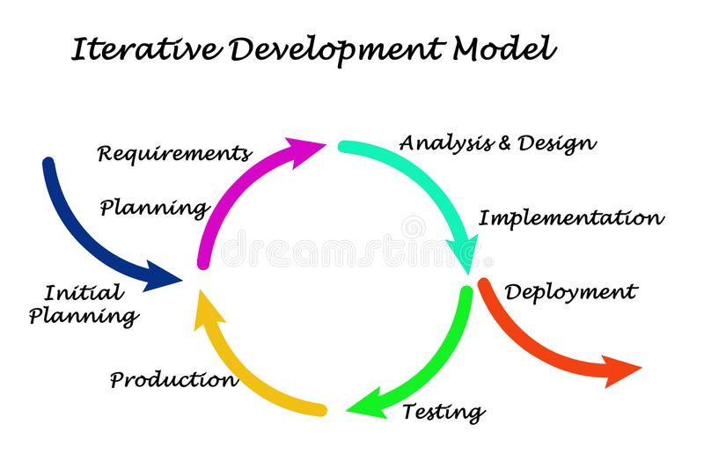

Figure 1: Iterative Model [7]

3.1.1. Requirement Analyze Phase
In requirement analysis phase, the different requirements that the final product was supposed to fulfill were determined, gathered and analyzed. The various requirements for our Neural Library were creation of perceptron, creation of feed forward neural network, implementing them, visualizing and finding better ways to demonstrate to non-technical user, finding right tools to use and gathering training data for pattern recognition of hand written digit. With successive iteration, this phase also involved the identification of requirements which were not fulfilled in the previous builds of the library, but are still needed for the development

3.1.2. Design Phase
In design phase, a software solution to meet the requirements gathered in the previous phase was designed. Design phase was largely comprised of designing structure of neural network during its creation, while implementation it for solving logical gate problem, finding pattern for predicting handwritten digits. At the later phase, we also created game, level, character and object design that is needed for implementing and testing of our Neuro evolution simulation and implementing library for disease prediction.

3.1.3. Coding Phase
In implementation phase, the software was coded as per the design pattern mentioned earlier. This phase involved the creation of new features, plus the upgrade and enhancement of previously coded feature as per the final requirements.

3.1.4. Testing phase
In this phase, the source code was built and tested in some sample devices to find out any errors that exist in the library. The library’s new feature was also tested. With each testing a list of changes to the library developed, is suggested and the changes will be applied to it. It was found that NN with the structure of large input, hidden or output nodes require large computational resource and power. Computer with low resource tend to hang and consume more time when testing the implementation of our library.

3.2. Tools and Technologies
Application software and tools used during the development of this project are:

S.N. | Name | Description/Purpose
1. | Python | Python is an interpreted, high-level, general-purpose programming language that lets you work quickly and integrate systems more effectively. It is the main programming language used in this project.
2. | NumPy | NumPy is a library for the Python. It adds support for large, multi-dimensional arrays and matrices, along with a large collection of high level complex mathematical functions to operate on these arrays.
3. | Matplotlib | Matplotlib is a plotting library for the Python and its numerical mathematics extension NumPy. It provides an object-oriented API for embedding plots into applications using general-purpose GUI toolkits like wxPython, Qt, or GTK+.
4. | TkInter | Tkinter is a Python binding to the Tk GUI toolkit. It is the standard Python interface to the Tk GUI toolkit, and is Python's de facto standard GUI. It is python library for creating animation.
5. | scikit-learn | Scikit-learn is a free software machine learning library for the Python. It features various classification, regression and clustering algorithms including support vector machines, random forests, gradient boosting, k-means and DBSCAN, and is designed to interoperate with the Python numerical and scientific libraries NumPy and SciPy. But we used it in our project for datasets only.
6. | Pillow | Python Imaging Library is a free library for the Python that adds support for opening, manipulating, and saving many different image file formats.
7. | Pygame | Pygame is a cross-platform set of Python modules designed for writing video games with physic engine and graphic. It includes computer graphics and sound libraries designed to be used with the Python programming language.
8. | Visual Studio Code, Vim | Visual Studio Code is a source-code editor developed by Microsoft for Windows, Linux and macOS. It includes support for debugging, embedded Git control and GitHub, syntax highlighting, intelligent code completion, snippets, and code refactoring. Vim is a clone, with additions, of Bill Joy's vi text editor program for Unix. They are the IDE used for writing and editing source code in this project.
9.

3.3. System Design
This section documents the various steps taken during the design phase of our library.
3.3.1 Class Diagram
A class diagram is a type of static structure diagram that describes the structure of a system by showing the system's classes, their attributes, operations (or methods), and the relationships among objects. The class diagrams of key elements of our library are shown in figure below:

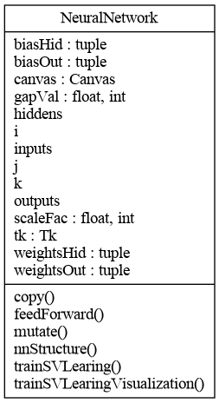
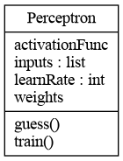

Figure 2: Perceptron Class Diagram

Figure 3: NeuralNetwork Class Diagram

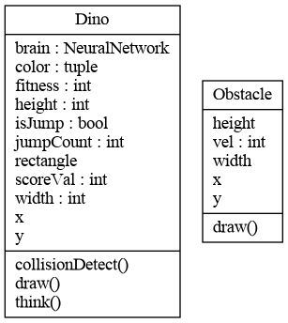

Figure 4: TRex game Class Diagram

3.3.2 Network Model Design

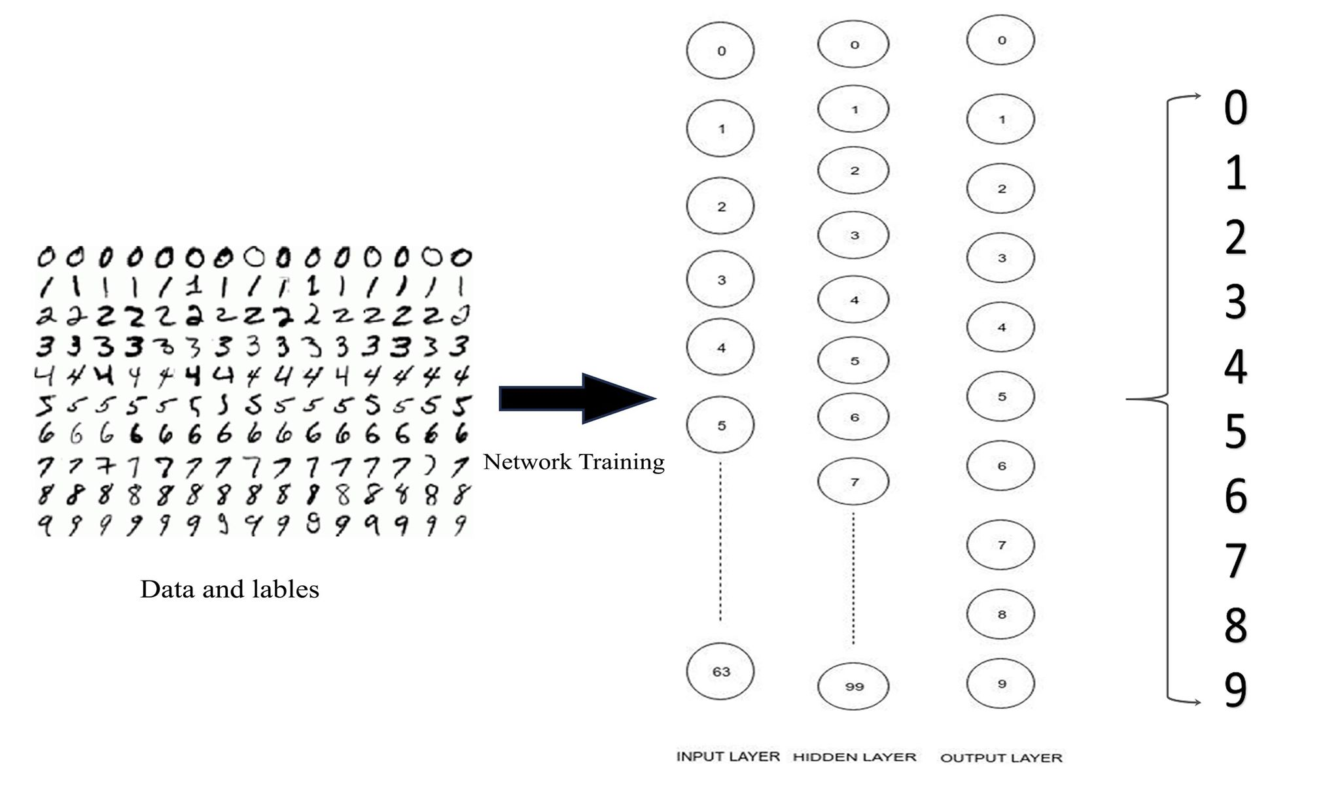
Figure 5: Image Recognition Model

The resolution of our training image of handwritten digit is 8x8 due to which there are 64 nodes in input layer, each representing pixel of an image. Second layer is hidden layer. It can contain any number of nodes. The more hidden nodes, the more data are needed to find good parameters, but the more complex decision boundaries can be found. Lastly, there is an output layer which contains 10 nodes. Each node in layer represents the output of the network which in our case is the prediction of the digit from 0 to 9.

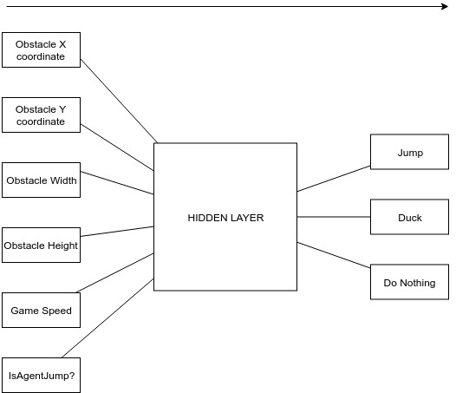

Figure 6: Learning Agent Model

To train our agent to play game, it needs to think as any human player does when playing any game. So, we need to pass the parameter that a player would look for when playing the game. In our Trex game, there are many factors that are looked for when doing any kind of action. We look for the coordinates of the obstacle, obstacle’s dimension, game’s speed and if our character is jumping or not. These inputs are pass to the network and it gives on any one of the output among jumping, ducking or do nothing.

4. TASK DONE SO FAR
As we have use Iterative methodology, our project was planned to complete in 4 phases. Phase 1st, 2nd and 3rd phases were completed so far. Phase 1 included creation of perceptron class, implementing it and finding its limitations. Phase 2 included the creation of a Neural Network Library. Phase 3 included the implementing and testing that NN Library in different tasks such as solving logic gates that perceptron was not able to do and pattern recognition. Some of the things done in each phase are explained below:

Phase 1 (Creation of Perceptron):
This phase included the development and implementation of perceptron and finding its limitations. We started by creating a class for perceptron. It includes constructor function that takes argument of number of input node and generates random weight based on it. It contains guess function that takes input data as argument; that sum the multiplication of weights and input values and pass it through activation function which generates the output. Finally, it contains train function that takes input data, known data and learning rate as argument. In this function, perceptron trains itself by changing weights and bias according to error between target and output of it.
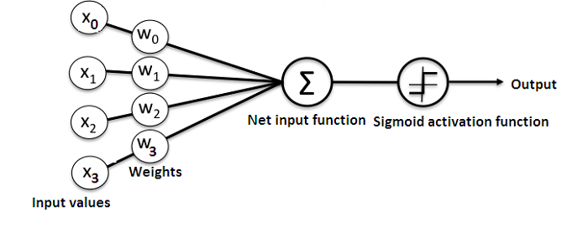
Figure 7: Perceptron
Implementation: After the creation of perceptron class, we needed to test it. We used this class to solve basic logical gates such as OR, AND, NOT, NOR and NAND. We even created visualization of it learning process and generation of output.
Limitation: Though perceptron was able to solve basic gates, but it cannot solve complex gate such as XOR and XNOR. It more technical term, perceptron is not able to solve non-linearly separable problems. This is why neural network comes into play.

Phase 2 (Creation of Neural Network):
This phase includes the creation of a Feed Forward Neural Network class. Creating neural network class is huge and can take time. So, we plan and separated difference mathematical concept and the function that are going to be used.
An NN comprises of the following components:
- An input layer that receives data and pass it on
- A hidden layer
- An output layer
- Weights between the layers
- A deliberate activation function for every hidden layer, we’ll employ the sigmoid activation function.

Constructor: This function takes number of input nodes, hidden nodes and output nodes as argument and generates random weight and bias according to them.

FeedForward: This function takes input vector as argument. These input vectors get multiplied with hidden layer weight matrix, added with hidden layer bias vector and passed through sigmoid function to generate hidden layer output matrix. Similarly, those hidden layer output matrix gets multiplied with output layer weight matrix, added with output layer bias vector and passed through sigmoid function to generate the final output vector.

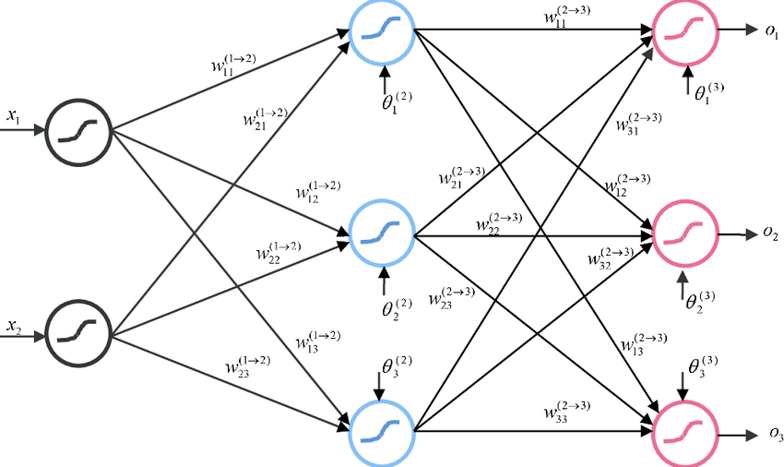

Figure 8: FeedForward Neural Network

Supervised Training: This function takes input vector, target vector and learning rate as an argument. Output vector from the given input vector is generated using above feedforward function. That output vector is compared with target vector and error vector is calculated. These are the output layer error. With output layer errors, we can calculate hidden layer errors. The output weight and bias matrix are modified according to output layer error using gradient descent [8]. Similarly, the hidden layer weight and bias matrix are modified according to hidden layer errors using gradient descent.

NN Structure: This function draws the network structure of the current Neural Network. It shows all the nodes in input, hidden and output layer. The lines drawn between nodes are weights. Weights with green color are positive weights and weights with red color are negative weights.

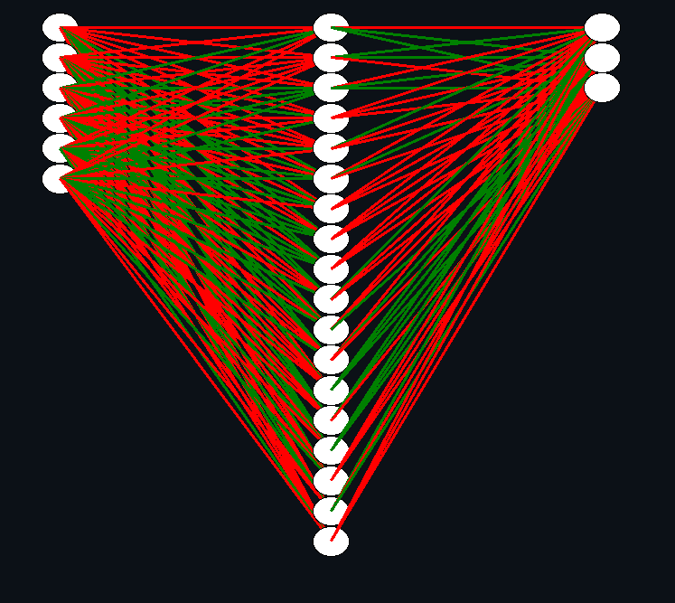

Figure 9: Neural Network Structure

NN Training Visualization: This function visualizes the training process of the network where weights and biases are constantly changing. This function is similar to supervised training function. It also takes input vector, target vector and learning rate as an argument. The only difference between these two function is supervised training process is done in background and it is fast compared to this function because of more resource use due to visualization of network.

Phase 3 (Implementation of Neural Network):
In this phase we tested and implemented NN class in different tasks such as solving logic gates that perceptron could solve. We visualize its learning phase and how it generates output. Later we wanted our library to test for pattern recognition. So we used sklearn datasets to get handwritten digit. We trained our NN with 1500 these data and tested with 200 data which was able to give accuracy around 80%. After training and testing, this program will provide a drawing canvas that allows user to draw which neural network will try to predict a digit based on that drawing. A new window will pop up when user hit save button that will show image that user drew and the predicted image of digit that NN was trained with.

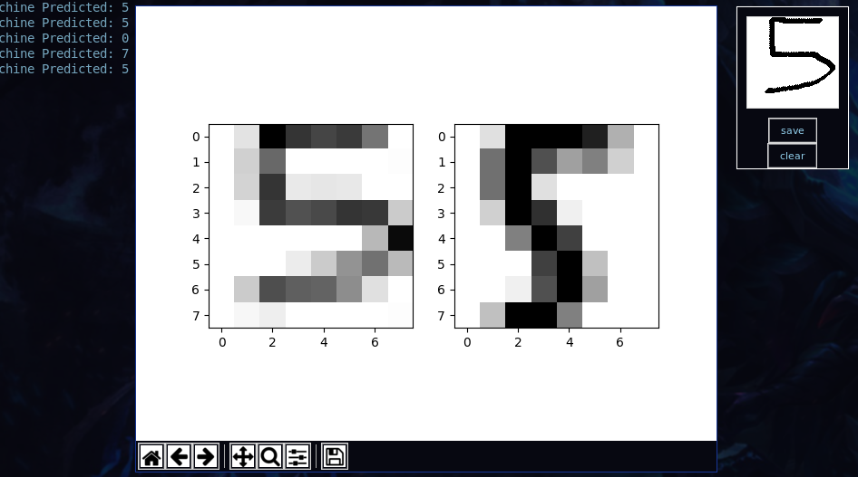
Figure 10: Digit Recognition Program

5. RESULT AND DECISION
The main goal of our project is to create a Neural Network library from scratch. As per our meeting, the project development was split up into 4 phases of which we have completed till the 3rd phase. In the 1st phase we discussed about perceptron on how it works and different methods in creating and implementing perceptron, what functions should be used and where to obtain the training data from. After extensive research and coding we were able to create a working perceptron which was able to solve and visualize basic logic gates. In the 2nd phase we decided to create a Neural Network library based on feed-forward neural network. The testing of the NN library was conducted in phase 3rd. In this phase we tested the NN library by implementation it to solve XOR gate problem. We discuss the idea of creating a canvas which four coordinate: (0,0), (0,1), (1,0) and (1,1) act as a input for the neural network. The color at the canvas acts as a output for an input. In the beginning, output colors are random. But slowly after training NN, it starts learning and gives right output to its corresponding inputs.



Figure 11: XOR gate Visualization

6. TASK REMAINING
Phase 4 (Evolving Neural Network):
This is our last phase for this project. We indent to use NEAT (Neuroevolution of augmenting topologies) algorithm that involves evolving neural network based on genetic algorithm. Neural network act as a brain for our game playing agent that perceive game environment, obstacle, and mechanism. With each generation, NN with the poor fitness value are filter out while the NN with high fitness value thrive to pass on its genes to next generation. This phenomenon is based on Darwin's Natural Selection which eventually leads to evolution of NN. With right amount of simulation, later generation can play the game at the pace human could only imagine.

7. DELIVERABLE/OUTPUT
At the end of the project, we’ll deliver a working Multilayer Neural Network library. It will contain algorithm such as Feed Forward for generating output, Back Propagation using Gradient Descent for supervised learning, visualization of neural network structure and NEAT algorithm. This library will be implemented by:

- Creating a program that will solve logical gate problem with visualization,
- Creating a program that will train NN with handwritten digits’ datasets and allow users to draw a image that will predict digit based on its training,
- Create a simple game and create learning agent with NN that will learn to play this game.

8. PROJECT PHASES AND TIME SCHEDULE

The project will be divided into six phases which were carried out according to the table below. The first phase will be requirement analysis where gather resource required for the project and will help in system analysis. In system analysis, feasibility study will be performed. The system design and modeling, coding and documentation will be performed thereafter. Several iterations will be carried out as per the iterative software development life cycle where implementation, test and review will be done. In final state, all the features added in each iteration will be reviewed, implemented and documented.
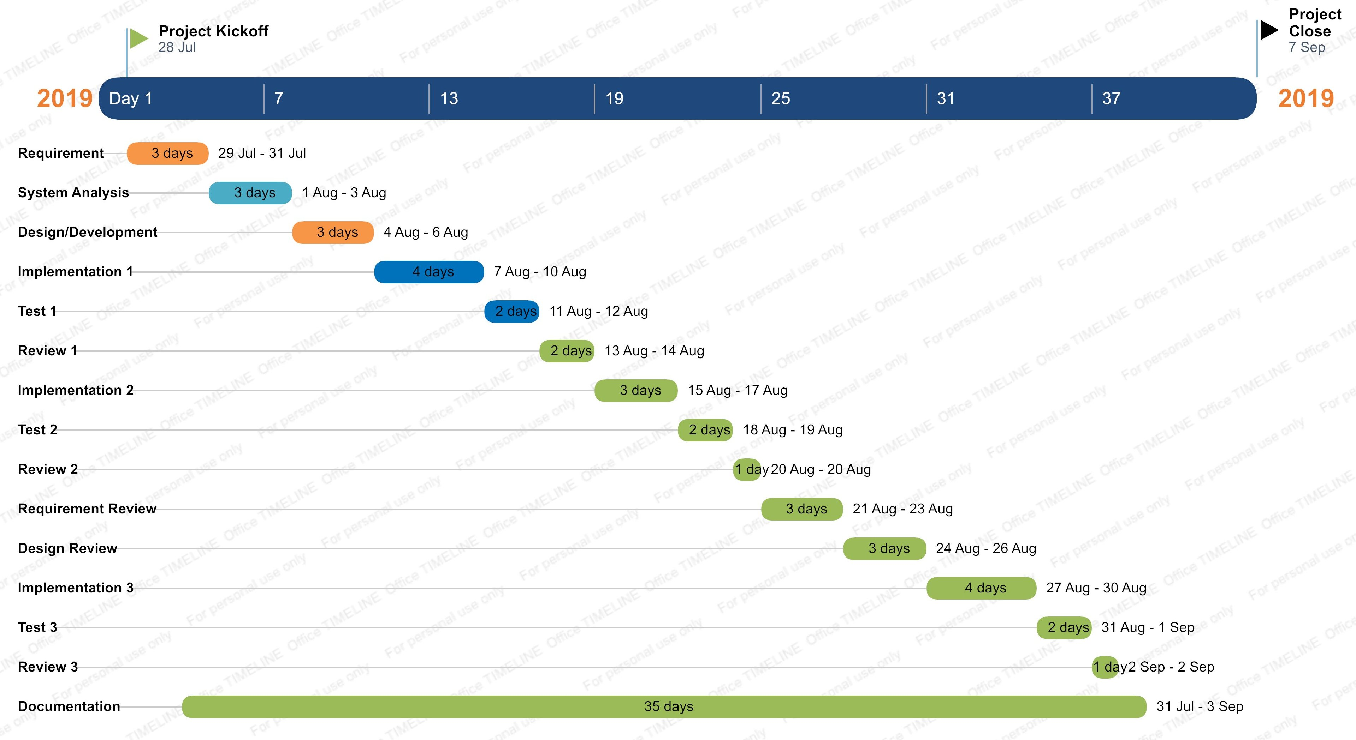
Figure 12: Gantt chart for overall phase

9. REFERENCES

[1] Perceptron (Basic Element of Neural Network) https://towardsdatascience.com/what-the-hell-is-perceptron-626217814f53 [Referred on 24th June]
[2] Neuroevolution of Augmented Topologies (NEAT) https://towardsdatascience.com/neat-an-awesome-approach-to-neuroevolution-3eca5cc7930f [Referred on 25th June]

[3] Tariq Rashid (2016). “Make Your Own Neural Network” https://www.goodreads.com/book/show/29746976-make-your-own-neural-network [Referred on 30th June]

[4] Neural Network (Two layer, Fully connected) https://github.com/nature-of-code/NOC-S17-2-Intelligence-Learning/tree/master/week4-neural-networks [Referred on 30th June]
[5] Genann: https://github.com/codeplea/genann [Referred on 20th July]

[6] Google’s TensorFlow: https://www.guru99.com/what-is-tensorflow.html [Referred on 22nd July]
[7] Iterative Model: https://www.dreamstime.com/iterative-development-model-components-image121519084 [Referred on 10th Aug]

[8] Learning by Backpropagation using Gradient Descent https://ml-cheatsheet.readthedocs.io/en/latest/gradient_descent.html [Referred on 13rd July]

